**Dumplings**

1. Image:

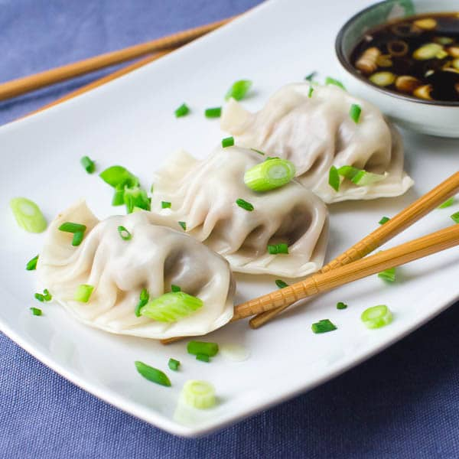

1. Name – Dumplings
2. Description

Dumpling is a broad classification for a dish that consists of pieces of dough (made from a variety of starch sources) wrapped around a filling or of dough with no filling. The dough can be based on bread, flour or potatoes, and may be filled with meat, fish, cheese, vegetables, fruits or sweets. Dumplings may be prepared using a variety of methods, including baking, boiling, frying, simmering or steaming and are found in many world cuisines.

1. Nutrition Fact

As mentioned before, Dumplings has different types. Here’s the example of one of the most popular one: Steamed Pork & Vegetable Dumplings:

**Nutrition Facts**

Serving Size

Top of Form

 pieces

Bottom of Form

**5 pieces = 145g**

**Amount Per Serving**

**280**

[**Calories**](https://www.myfooddiary.com/nutrients/calories)

**% Daily Value\***

12%

[**Total Fat**](https://www.myfooddiary.com/nutrients/fat)**8g**

13%[Saturated Fat](https://www.myfooddiary.com/nutrients/saturated-fat) 2.5g

[Trans Fat](https://www.myfooddiary.com/nutrients/trans-fat) 0g

**8%**

[**Cholesterol**](https://www.myfooddiary.com/nutrients/cholesterol)25mg

**28%**

[**Sodium**](https://www.myfooddiary.com/nutrients/sodium)640mg

**13%**

[**Total Carbohydrate**](https://www.myfooddiary.com/nutrients/carbohydrates)38g

7%

[Dietary Fiber](https://www.myfooddiary.com/nutrients/fiber) 2g

[Sugars](https://www.myfooddiary.com/nutrients/sugar) 4g

[**Protein**](https://www.myfooddiary.com/nutrients/protein)12g

2%[Vitamin A](https://www.myfooddiary.com/nutrients/vitamin-a) 100 IU

20%[Vitamin C](https://www.myfooddiary.com/nutrients/vitamin-c) 12mg

4%[Calcium](https://www.myfooddiary.com/nutrients/calcium) 40mg

6%[Iron](https://www.myfooddiary.com/nutrients/iron) 1.1mg

*

The % Daily Value (DV) tells you how much a nutrient in a serving of food contributes to a daily diet. 2,000 calories a day is used for general nutrition advice.

1. Purchase Links:

<https://www.orientalmart.co.uk/fresh-asia-brand-dumplings-pork-and-chinese-leaf->

1. Recipe links

<https://www.chinasichuanfood.com/how-to-make-dumplings/>